**Term Paper**

**ECON 8220: Seminar in Macro Theory, Fall 2019**

**Unemployment, Labor Force Participation and the Natural Rate of Unemployment**

**Submitted by Lucas Wagoner**

**To**

**Professor Mark Wohar**

**November 19th, 2019**

**Section I – Introduction**

Unemployment imposes significant deadweight costs on the individual and society. Long periods of high unemployment reduce income and drive the economy away from potential output. Unemployment benefits are costly for firms and countries to provide. Often, high unemployment can lead to calls for trade protection or immigration controls. On the other hand, very low levels of unemployment can cause accelerating inflation. For these reasons, among others, the unemployment rate is a very important indicator of the health of an economy.

Over the last 100 years, the unemployment rate has been tremendously volatile over some short-run periods. For example, the Great Depression and the Great Recession had very high unemployment rates while World War I and World War II were periods of low unemployment. Recently, the unemployment rate has steadily dropped to historical lows during the recovery from the Great Recession. Due to the volatility of the business cycle, economists estimate a hypothetical natural rate of unemployment where aggregate production is optimized, prices are stable and there is no tendency for inflation to accelerate or decelerate. These estimates of the long-run natural rate measure frictional and structural unemployment while omitting cyclical unemployment. If properly estimated, the natural rate of unemployment can provide clues to policy makers regarding where actual unemployment will gravitate to and additional insight on inflation and output trends. For example, we are currently amid a very long economic expansion with low levels of unemployment. Traditionally, we should expect to see increasing inflation however inflation has remained very low. If the natural rate of unemployment is higher than assumed, it may help to explain why there is a relative lack of wage-push inflation pressure at present.

Moreover, the natural rate of unemployment definition implies that the actual unemployment rate cannot be lower than the natural rate of unemployment permanently. However, the natural rate of unemployment can be reduced by eliminating market imperfections to structural unemployment. Therefore, policymakers interested in reducing unemployment permanently should analyze the economy’s structural components, such as labor force demographics or labor supply and demand trends, to examine whether the benefits of lowered unemployment are worth the costs. The remainder of this paper will examine these topics surrounding the natural rate of unemployment in greater detail. Section 1 will discuss the estimated natural rate of unemployment over the last one hundred years. Section 2 will present challenges to estimating the natural rate in real time. Section 3 will discuss the individuals ‘lifecycle’ of unemployment. Section 3 will discuss labor force participation and supply and demand trends since the great recession. Section 4 will discuss automation and technological advancement. Section 5 will provide concluding remarks.

**2 – The Natural Rate of Unemployment**

There is always some unemployment as workers change jobs. This frictional unemployment can represent a healthy economy. As workers and employers search and find better matches, they find roles or employees that better suit their skills or needs and productivity increases. In addition, some workers will exit the workforce for various reasons; to care for children, to retire, or to return to school to enhance their skills. As a result, the lowest level of unemployment is not zero but rather changes over time based off the demand, supply and composition of the labor force. The natural rate of unemployment, sometimes referred to as the non-accelerating inflation rate of unemployment (NAIRU) or simply U-star (**U\***) represents a hypothetical level of unemployment rate expected to prevail over the long run given the current state of the economy, after any short-run shocks affecting the economy dissipate. For brevity, the natural rate of unemployment will hereafter be referred to as **U*.**

**2.1 U* Historically**

Using historical data on unemployment and inflation going back to 1890, Regis Barnichon and Christian Matthes from the Federal Reserve Bank of San Francisco (2017) estimate U* finding it to be remarkably stable over the past 100 years, with a range between 4.5 and 5.5% (Figure 1). Their results show almost one in four prime-age workers was unemployed during the Great Depression, but the natural rate of unemployment only increased by 1%. Barnichon and Matthes suggest two main reasons: a rapid decline in inflation, signaling a large unemployment gap and the lead-up to World War II which caused employment increased rapidly to its pre-depression level quickly. Their model interprets the Great Depression as a cyclical shock--not a structural change. Similarly, World War II had little effect on the natural rate even though the actual unemployment rate dropped to less than 1%. In this case, when the labor market tightened, inflation rose as predicted by the Phillips Curve. In the post-war era, their natural rate increases then decreases with the lifecycle of the baby boomer generation from 1960 to 2000. The historical analysis paints a good picture of U* over time. An important caveat to note is policymakers do not have the benefit of hindsight and must make future projections of U* when setting policy or analyzing the economy. As the next section will explore, this creates some challenges when evaluating the natural rate of unemployment.

**Section 2.1 – Estimating the Natural Rate in real time**

Economists measure the degree of labor market slack by comparing the actual unemployment rate to U*. If policymakers desire lower or higher unemployment, they must base their estimates of U* on data available to them in the present which is almost always later revised. Murat Tasci (2019) investigates how these revisions have affected estimates of U* over the past decade by comparing four estimates of U*: Tasci’s own flow-model estimate, the Congressional Budget Office estimate, the Survey of Professional Forecasters estimate (SPF), and the Federal Open Market Committee projections, referred to as the Summary of Economic Projections (SEP). The survey of Professional Forecasters (SPF) is a quarterly survey of forecasters from the private sector and academia that is conducted by the Federal Reserve Bank of Philadelphia.

Both the SPF and SEP estimates are real-time assessments of U* representing the participants best forward-looking judgment of U*. These surveys do not provide retrospective estimates of U*. On the other hand, the Congressional Budget Office updates past projections and provides them in their releases with the whole history of its U* estimates. So, the real-time estimate for 2015 could be different than in the most recent update. Similarly, the flow-model estimate in real time could be different from the most recent estimate because the underlying data is revised.

Tasci evaluates estimates of U* over the past recession and find they were relatively close to each other (Figure 2). In Q4, 2007 the U* estimates ranged from 4.5 percent to 4.8 percent while actual unemployment was 4.8 percent. By the end of the recession in 2009:Q2, unemployment hit 9.3 percent while U* remained within a narrow band of 4.8 percent to 5.1 percent. However, starting in 2010, the real-time estimates began to diverge. Next, Tasci analyzes how much real-time estimates differ from current estimates. He finds revised estimates of U* from the flow-based model and CBO are virtually indistinguishable from 2010 to 2017. However, U* estimates from both sources are significantly different from their real-time counterparts. He concludes that real-time flow-model estimates of U* would have led to overestimation of labor market slack prior to the recession whereas U* estimates from both sources would have led to underestimating labor market slack for a period during the recovery.

His study shows current estimates of U* for the past recession and recovery differ from estimates made using real-time data so therefore it is not easy to gauge how much slack there is in the labor market, particularly the closer one gets to present time. In this instance, specifically, Tasci states they did not know how exceptionally low job-finding rate would be. This suggests economists underestimated the level of labor market slack during the recent recovery period. In retrospect, both the CBO and flow-model estimates of U* are lower than their real-time estimates, suggesting labor markets were not as tight as previously thought. As Tasci’s study reveals, it may be easy to see what policy prescriptions should have been 10, 20 or 30 years ago but it is much more challenging to determine what policy should be when looking into the future. His analysis of the last decade further shows that more recent U* estimates are likely to have a higher variation compared to historical U* estimates. In other words, it would be optimal for policy setters to be conservative when attempting to alter the unemployment rate because their miscalculations may have a large impact in the short-run but not in the long-run. Policymakers who intend to change U* should instead look to the composition of the labor market.

**Section 3 – Labor Market Composition**

**3.1 – The ‘Lifecycle’ of Unemployment**

Demographics, technological advancement and increasing globalization, can cause the natural rate of unemployment to vary. The unemployment rate today could signal a slack in the labor market, while may signal a tighter labor market. Michael Morris, Robert Rich and Joseph Tracy of the Dallas Fed (2019) estimate a life-cycle profile of unemployment to explain how demographic changes may change the U*. Morris, Rich, and Tracy examined data on 35 million individuals obtained from the Current Population Survey over the years 1976 to 2018. They follow 360 cohorts of workers over their careers where each cohort is based on the individual’s decade of birth, sex, race or ethnicity and level of education.

Initially, for all cohort’s unemployment rates are relatively high (Figure 3). Young individuals are entering the workforce for the first time and have little on-the-job training. As people secure employment, they become more attached to the labor force and all cohort’s rates of unemployment decline gradually, until around the mid-40s where there is a slight uptick, then gradually declines again until an individual reaches retirement age. Overall, this implies that as a workforce skews older, unemployment is less likely and thus lowers the U*. This is supported by the historical estimate of U* by Barnchion and Mathes mentioned above which mirrored the lifecycle of the large baby-boomer generation.

Educated workers have more attachment to the labor force (Figure 3). Individuals with less than a high-school diploma have dramatically higher rates of unemployment than other education groups which endures throughout a cohort’s lifetime. For example, when individuals without a high-school diploma are at the period of life where their unemployment rate is the lowest, their unemployment rates still exceed the unemployment rate of individuals with a college degree first-entering the workforce at the period when their unemployment rates are the highest. Interestingly, individuals with post-college degree have only slightly lower unemployment rates to those with a college degree which implies the decision to pursue an advanced degree is determined by the desire for increased earnings or personal interest rather than job security.

Unemployment varies by race (Figure 4). Whites and Asians have generally lower levels of unemployment than Hispanics but there is not a considerable difference between the three cohorts and this difference largely disappears by age 50. Meanwhile, blacks have radically higher levels of unemployment at all ages compared to other races. The difference does narrow over time and by retirement age is essentially comparable to the other cohorts, though still the highest.

Women have lower rates of unemployment than men if both have less than a college degree. If both sexes have a college degree this relationship reverses (Figure 5). Given lower unemployment rates for many women, the rapid rise of female labor force participation in the 1960s to 1980s is a factor in reducing U*.Moreover, Didem Tuzeman and Thao Tran (2019) compared changes in labor market outcomes over the great recession and recovery across sex and education levels decomposed into four groups: non-college men, college men, non-college women, and college women. They find increases in labor force participation rates during the late-recovery period are due to a declining number of men and women without bachelor’s degrees and not employment gains. Also, they find only college women have seen their labor force participation rate recover to its pre-recession level.

**3.2 Analysis**

The cohort of individuals obtaining less than a high school degree have significantly higher unemployment rates than other cohorts. Similarly, black individuals have significantly higher levels of unemployment compared to Asian, Whites or Hispanics. Therefore, policy solutions aimed at reducing the level of individuals with less than a high school diploma or improving black people’s attachment to the workforce have the largest room for opportunity. In addition, the difference in life-cycle unemployment between the cohorts of bachelor’s degree and graduate degree is negligible. This suggests that policy makers looking to increase productivity should focus on influencing people into more productive industries rather than pursuing advanced degrees in less productive industries. Unfortunately, it is difficult for both society and individuals to properly select the right degree. An analysis of the life-cycle of unemployment highlights important differences in unemployment rates for different demographics of the economy but it does not explain the factors driving employment change since the Great Recession. Reviewing the composition of labor supply and demand over the last decade can provide more insight into the direction of the labor market and therefore the natural rate of unemployment.

**4.1 Job Polarization**

A shift in labor demand toward jobs that favor the skills and education of prime-age individuals explains some of these changes. Didem Tüzemen (2019) finds the employment share of middle-skill jobs has declined significantly, while the low and high skill job shares have increased. She deems this aggregate shift in employment away from middle-skill jobs and toward low and high-skill jobs “job polarization”.

Technological advancements help explain why the middle-skill job share has fallen so sharply. Many middle-skill jobs are routine; workers perform procedural and rule-based tasks that are easier to replicate. The tasks performed in many of these jobs have been automated, which will be discussed in further detail below. In addition, increased international trade has contributed to the decline in routine jobs. Many of these roles have been off-shored to coun­tries where workers can perform similar tasks for lower wages (Goos and others 2011; Oldenski 2012). Meanwhile, workers high-skill workers perform tasks requiring analytical and problem-solving ability which cannot be offshored or automated as easily. Work­ers in low-skill manual jobs typically have no formal education beyond high school and work in physically demanding jobs. As a result of this job polarization, Tüzemen shows almost all job-gains since the Great Recession have accrued to college-educated individuals. In contrast, the shift in the composition of jobs toward high-skill jobs during the recovery increased employment and labor force participation among college-educated individuals, particularly women.

Workers have responded to job polarization and shifting employment opportunities by increasing the amount of education they obtain: The large increase in the share of individuals with a bachelor’s degree was accompanied by an increase in their share in the labor force. A larger share of women has obtained a bachelor’s degree than men so the share of non-college women in the labor force has declined by more than the share of non-college men, although non-college men still have the largest share in the labor force. (Figure 6)

Meanwhile, the most common reason for leaving the labor force report­ed by women of all education levels was taking care of family while men without a bachelor’s degree most common reasons were disability or illness. For men with a bachelor’s degree, the most common situation reported was being in school (Tuzeman). Consistent with job polarization, men and women without bachelor’s degrees may have a harder time returning to the labor force because they are unable to find jobs suitable for their skills and education levels (Cortes and others 2015; Foote and Ryan 2015). The stress of long-term unemployment or inactivity could lead to mental or physical problems, which may contribute to men reporting disability or illness as their reason for non-participation.

As mentioned above, family care, remains a major obstacle among women, regard­less of their educational attainment. In order to overcome this obstacle, family-friendly policies such as subsidies for child day-care services or enhanced work-leave benefits could be instituted. Results from other countries in the OECD such as France, Canada, the United Kingdom, and Japan (Black and others 2017) does show this is possible. Their research shows family-friendly policies in these countries have been successful in pulling more women into the labor force, suggesting family-friendly labor market policies could also help increase labor force par­ticipation among women in the United States. For men, a lack of job opportunities may lead to depression and illness. These health conditions may become further barriers to em­ployment. Similarly, a lack of affordable family care may prevent many women from joining the labor force. In addition, the economy has ‘polarized’ where it has become almost essential to obtain a bachelor’s degree or other specialized education to secure consistent employment. Policies geared toward equipping workers skills and education demanded by employers, or toward providing support for family care, may encourage higher par­ticipation among individuals.

**4 Automation**

A strong labor market and low unemployment traditionally help boost wages. But in the past two decades, the labor share—the portion of national income going to workers—has declined from about 63% in 2000 to 56% in 2018 (Leduc, Sylvain and Zheng Liu 2019). This decline accelerated during the Great Recession and remains at historically low levels. Lost bargaining power is one possible cause of the decline in the labor share as union membership declines and low wages in impoverished countries makes foreign workers more competitive to employ for businesses. Another factor is automation. Businesses have more options to automate positions now than in the past. The steady decline in the prices of automation equipment over time has made it increasingly profitable to automate. Rapid advances in robotics and artificial intelligence allow robots to perform more jobs and tasks that previously required human skills.

Traditionally, productivity improvements trigger rising wages because wages would adjust until the labor supply meets labor demand, leading to full employment. Leduc, Sylvain and Zheng Liu show this prediction is inconsistent with recent data: the decline in the labor share since the early 2000s has been accompanied by stagnant wage growth.

In their study, Leduc, Sylvain and Liu develop a more realistic model of the labor market featuring wage bargaining and job search frictions that capture the reality of businesses and workers searching for suitable employment matches and that searching is costly. Business post vacancies and interview candidates while workers search ads, send resumes and interview. These search costs imply both businesses and workers have a wage band they would agree upon in forming a job match in order to avoid extended search costs. The ultimate wage depends on the bargaining power between employers and workers. Therefore, wage rates, do not exactly coincide with marginal product; some employed workers stay in current positions to avoid any search costs required to find a new job while employers retain less productive employees to avoid similar search costs. In this environment, automation can give employers additional bargaining power by reducing their search costs. Because this benefit does not accrue to workers as well, their search costs remain high and ultimately decrease the labor share of income. Leduc, Sylvain and Liu suggest that the probability that businesses will automate a job position is procyclical, rising in expansions and falling in recessions, because the net benefits of automation are procyclical. The decline in workers bargaining power acts as a drag on wage increases. Their model further implies that if automation had not been a part of the last two decades, productivity would have risen less while wages would have risen more (Figure 7). They find that although automation is a drag on labor share, it has a positive impact on aggregate employment and has contributed to the steady decline in unemployment in recent years. In other words, automation eliminates some jobs and generates others.

Their model is supported by other studies. David Autor and Anna Salomon’s (2018) used data from 28 industries across 18 developed countries to show that automation has had a significant negative impact on the labor share, particularly since the early 2000s. In addition, Dinlersoz and Wolf (2018) document that business establishments with more investment in automation experienced greater productivity gains but also larger declines in their labor shares.

**4.1 Analysis**

Over the last decade, automation has carved out the ‘middle-skill’ job share, leaving a polarization of workers: Highly educated and skilled workers have skills that are not easily replicated and cannot currently be automated. As a result, they have high demand in the labor force and can secure higher wages from firms in need of their skills. Mid-skilled workers are being squeezed out by automation; some middle skill workers can transition into high-skill employment while some transition into low-skill employment. As technology continues to advance, policymakers will have to find new ways for workers to enhance their productivity so they can reclaim the lost share of income. Alternatively, welfare policies could be implemented to support marginalized workers.

**Section 5—Conclusion**

The economy does grow in starts and stalls as the business cycle drives the economy into expansion then contraction. As workers and firms adapt to changing conditions, they adjust their wage and inflation expectations and the economy gravitates back toward the natural rate of unemployment. Along the way, the actual unemployment rate will follow a similar pattern; at times the unemployment will be relatively high or relatively low. Meanwhile the structural components of an economy, labor force demographics or labor demand, do not change as rapidly nor is the change as volatile. As a result, the natural rate is largely stable throughout time with an estimated range around 4.5-5.5%. This implies that fiscal and monetary policies cannot be used to permanently lower the unemployment rate below its natural rate. However, as mentioned above, the natural rate itself can be lowered through policies aimed at its sources although whether it is beneficial to do so is cause for debate.

Lowering the natural rate would produce several clear benefits. More output would be generated, and the federal budget deficit would narrow through increased tax receipts. Simultaneously, unemployment benefit expenditures would decrease. At the individual level, individuals would endure less hardship that comes with long-term unemployment. Increased employment would provide workers with more on-the-job training and they would become even more attached to the labor force. Finally, fiscal or monetary policymakers at the White House or the Federal Reserve would be under less pressure to use policies to maintain an unsustainable and potentially inflationary unemployment rate. Some of the market imperfections mentioned above that underlie the sources of structural unemployment are demographic changes and skill mismatches due to job polarization. Certain aspects of these sources can be modified.

Demographic changes have a large impact on structural unemployment. As mentioned above, the natural rate of unemployment mirrored the baby boomer generation. Currently, the baby-boomer generation is at the tail end of their life-cycle of unemployment. As younger people are not having as many children as past generations, the labor ageing out of the workforce is not being replaced. The workforce will skew younger implying increased unemployment rates and may also lead to reduced productivity. One option to increase the pool of the labor force is favorable immigration policy. By opening the nation’s borders, an inflow of workers from abroad could somewhat offset the lost productivity from demographic shifts. In addition, Immigrants from impoverished countries may be willing to accept jobs and wages that Americans do not. Policy makers could also turn to policies that increase the capacity of the current labor force. For example, the most common reason for women to exit the work force is to rear children or care for the elderly. Enhanced social services that provide child care have been implemented in other industrialized countries and could provide an avenue for women to return to work. For men, social services to alleviate mental health conditions could be developed. For the workforce, universal health care could be implemented to maintain the health of a workforce. There is no doubt these benefits would be extremely costly for the government to provide so there should be a heavy amount of criticism to insure these polices are implemented successfully, if at all. In addition to increasing the size of the workforce, it would be beneficial to increase the productivity of the existing labor force.

Skill mismatch unemployment would decline if available workers were better educated and better trained. For example, policies that reduced the number of individuals without a high-school diploma could be very beneficial. Vocational training programs to acquire training at technical schools or better elementary education for low- and middle-income youths are potential solutions. In addition, as a result of automation and technological advancement, the labor-force was greatly ‘hollowed out’. Programs designed to encourage on-the-job training for middle-skilled workers (as well as low-skilled workers) who were squeezed out due to automation would be effective in increasing the skills of the existing labor force.

Other labor market imperfection such as minimum wage laws or discrimination in hiring prevent labor markets from working as efficiently as possible. Policy makers may find it politically untenable or socially unacceptable to eliminate the minimum wage entirely, however minimum wage laws have adverse impacts on employment prospects of low-skilled, low-wage individuals. Wages are higher than they otherwise would be causing employers to hire fewer workers and causing more individuals to enter the labor force resulting in an excess supply of low-skilled, low-wage individuals, ultimately increasing unemployment. As younger cohorts have the highest unemployment rates, an option could be to lower the minimum wage for teenagers or early 20’s individuals, or provide subsidies for internship programs that give this cohort on-the-job training

Racial and sexual discrimination in hiring has a similar impact; qualified individuals are shut out of potential positions and lose valuable on-the-job training in the process. Abolishing discriminatory hiring, or enforcing existing discrimination laws more regularly, would all lower the natural rate.

In conclusion, the natural rate of unemployment is a hypothetical unemployment an economy can sustain without a tendency for inflation or deflation. Essentially, the estimates of the natural rate attempt to analyze structural unemployment while omitting cyclical unemployment. This rate has remained relatively consistent over the last one hundred years while the actual unemployment rate has fluctuated. Estimates of the natural rate of unemployment vary which imposes challenges on policymakers who must set policy in real-time. Structural components that affect the natural rate or labor force demographics and labor demand trends. As a labor force skews older and more educated, they have lower rates of unemployment. Whites and Asians have relatively lower rates of unemployment while Hispanics have higher levels. Blacks have the highest level of unemployment however these differences become muted as an individual age. The Great Recession caused job polarization which affected middle-skill workers. Employment shares shifted towards high-skilled and low-skilled occupations. There are several policy options available to policymakers to offset these changes however they are costly or politically challenging. In the face of constant technological, demographic shifts and automation, policymakers must be prepared to make tough choices.

Figures

**Figure 1**

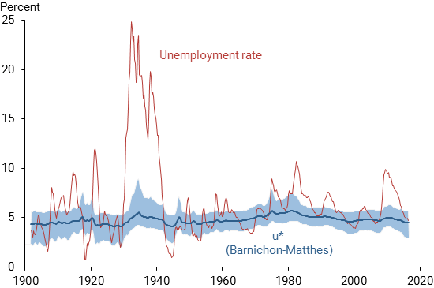

Figure 2

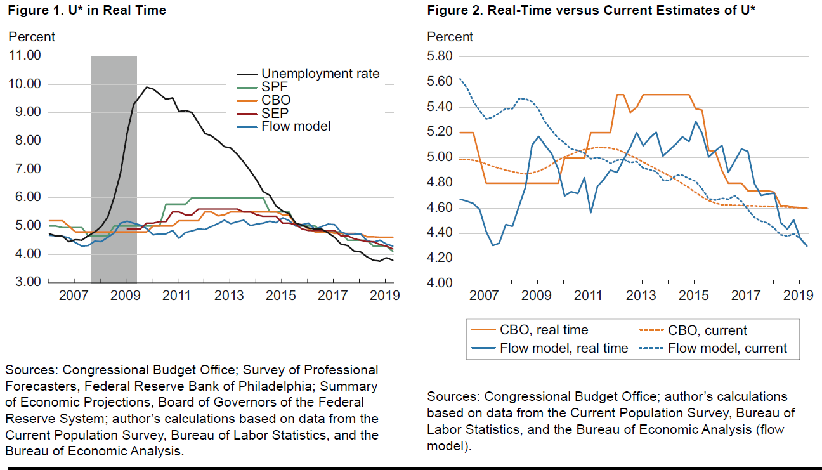

Figure 3

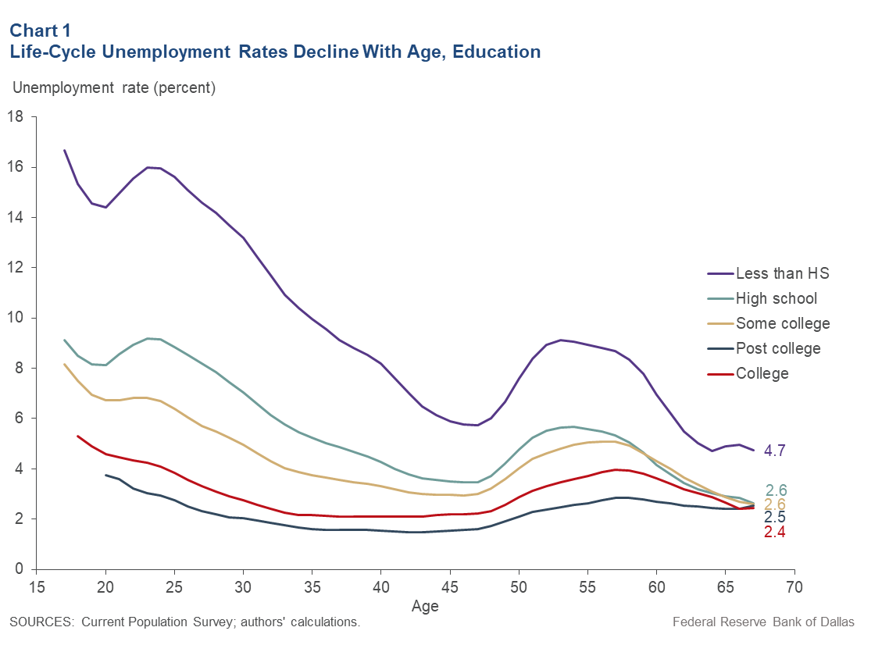

Figure 4

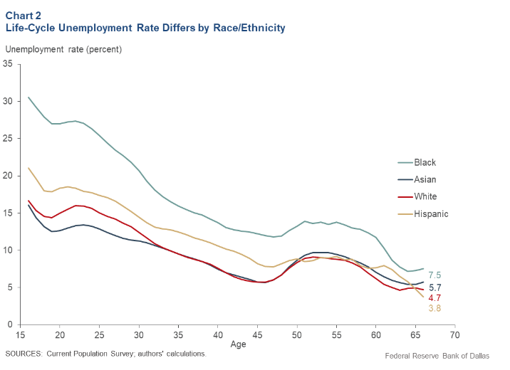

Figure 5

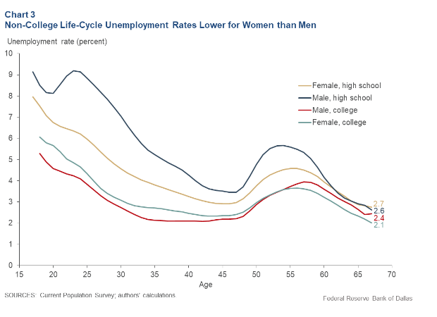

Figure 6

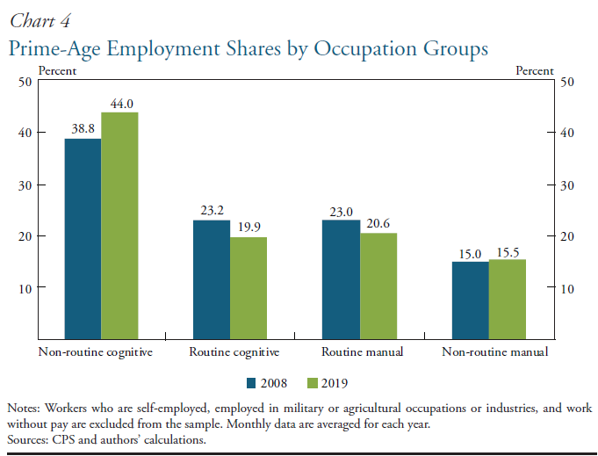

Figure 7

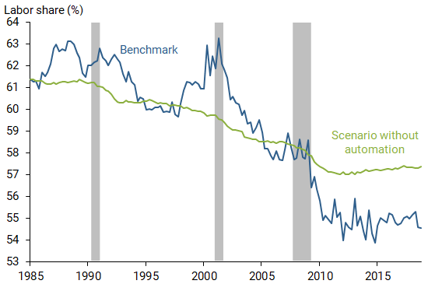

Sources

**Autor, David, and Anna Salomons.** 2018. [“Is Automation Labor-Displacing? Productivity Growth, Employment, and the Labor Share.”](https://www.brookings.edu/bpea-articles/is-automation-labor-displacing-productivity-growth-employment-and-the-labor-share/) Brookings Papers on Economic Activity, Spring, pp. 1–87.

**Berrichon, Regis and Christian Matthews**. 2017. “The Natural Rate of Unemployment over the Past 100 Years.” Federal Reserve Bank of San Francisco <https://www.frbsf.org/economic-research/publications/economic-letter/2017/august/natural-rate-of-unemployment-over-past-100-years>

**Black, Sandra E., Diane Whitmore Schanzenbach, and Audrey Breitwieser**. 2017. “The Recent Decline in Women’s Labor Force Participation,” in Diane Whit­more Schanzenbach and Ryan Nudd, eds., *The 51%: Driving Growth through Women’s Economic Participation*, pp. 5–17. Washington, DC: Brookings In­stitution, Hamilton Project.

**Cortes, Guido Matias, Nir Jaimovich, Christopher J. Nekarda, and Henry E. Siu**. 2015. “The Micro and Macro of Disappearing Routine Jobs: A Flows Ap­proach.” National Bureau of Economic Research, working paper no. 20307, July. Available at <https://doi.org/10.3386/w20307>

**Dinlersoz, Emin, and Zoltan Wolf**. 2018. [“Automation, Labor Share, and Productivity: Plant-Level Evidence from U.S. Manufacturing.”](https://www2.census.gov/ces/wp/2018/CES-WP-18-39.pdf) U.S. Census Bureau Center for Economic Studies Working Paper, pp. 18-39.

**Foote, Christopher L., and Richard W. Ryan**. 2015. “Labor-Market Polarization over the Business Cycle.” *NBER Macroeconomics Annual*, vol. 29, no. 1, pp. 371–413. Available at <https://doi.org/10.1086/680656>

**Goos, Maarten, Alan Manning, and Anna Salomons**. 2011. “Explaining Job Po­larization: The Roles of Technology, Offshoring and Institutions.” Center for Economic Studies Discussions Paper Series no. 11.34, December. Available at <https://doi.org/10.2139/ssrn.1983952>

**Leduc, Sylvain and Zheng Liu 2019**. “Are Workers Losing to Robots?” Federal Reserve Bank of San Francisco. <https://www.frbsf.org/economic-research/publications/economic-letter/2019/september/are-workers-losing-to-robots/>

**Morris, Michale, Robert Rich, Joseph Tracy**. 2019. “A Natural Approach to Estimating the ‘Natural Rate of Unemployment” Federal Reserve Bank of Dallas. <https://www.dallasfed.org/research/economics/2019/1008>

**Oldenski, Lindsay**. 2012. “Offshoring and the Polarization of the U.S. Labor Market.” Georgetown University, working paper, May.

**Tasci, Murat**. 2019. “Challenges with Estimating U Star in Real Time”. Federal Reserve Bank of Cleveland.<https://www.clevelandfed.org/en/newsroom-and-events/publications/economic-commentary/2019-economic-commentaries/ec-201918-u-star.aspx>

**Tuzemen, Didem and Thao Tran**. 2019. “The Uneven Recovery in Prime-Age Labor Force Participation”. Federal Reserve Bank of Kansas City. <https://www.kansascityfed.org/~/media/files/publicat/econrev/econrevarchive/2019/2q19vanzandweghe.pdf>